Name___Key_________________________Date__________________Period____________
Information from the presentation: Of Light and Lasers
Short Essay Questions
Video: The Original Double Slit Experiment- What is Light and How does it Travel as a Particle or a Wave?
Before the Video | After the Video | Analyze Thoughts
1. What is Light? (slide 3) | 2. After watching the video, answer the question again: What is Light? (slide 4) | 3. Did the video change your thoughts on “What is Light”? If so how? (slide 4)
Answers will vary | Light is part of the electromagnetic spectrum, which ranges from radio waves to gamma rays.  Light is composed of photons that move in waves  The human eye can see the visible spectrum and colors seen are from the wavelengths reflected off matter and to your eye. | Answers will vary
4. How do You Think Light Travels? (a wave, a particle or how?) (slide 3) | 5. After watching the video, answer the question again: How do you think light travels? (slide 4) | 6. Did the video “How you think light travels”? If so how? (slide 4)
Answers will vary | Light is composed of particles (photons) that travel in waves.  Light travels as a wave with components of: crests, trough, amplitude, and wavelength.  Interacting Light waves can undergo destructive and constructive interference. | Answers will vary

Fill in the blanks on the following:
7. Visible light is part of the ___electromagnetic spectrum____. (slide 5)
8. Light is composed of _photons__that move in __waves____. (slide 5)
9. Colors that are seen are ____reflected_______ to the eye. (slide 5)
10. Light and electromagnetic waves do not require a _medium__to travel. (slide 5)
11. The speed of light and electromagnetic waves is approximately ____3.0 X 10⁸ m/sec_____. (slide 6)
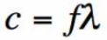
12. The formula to calculate the speed of light & electromagnetic waves is speed=frequency times wavelength. (slide 6)
13. Visible light has a range of wavelengths between ___400 nm___ and ___700 nm_____. (slide 7)
Short Essay Questions
Video: How a Laser Works
Before the Video | After the Video | Analyze Thoughts
14. How does a laser work? Write your answer based on what you know or think. (slide 9) | 15. After watching the video, answer the question again: How do you think a laser works? (slides 10-11) | 16. Did the video change the way you think about light? If so how? (slides 10-11)
Answers will vary | Photons from an external source excite the electrons of atoms in the laser rod.  excited electrons move from a lower-energy orbit to a higher-energy orbit  when electrons return to their normal or “ground” state, the electrons emit photons  Coherent focused photons leave the rod through a slit in the mirror | Answers will vary

Fill in the blanks on the following:
14. ___Electrons___ give off __photons____ as they drop from an excited state to a lower state. (slide 12)
15. _Theodore H. Maiman __invented the first working laser in ___1960_______. (slide 12)
16. Light from a laser is _a single__ color, meaning _the same_ wavelength. (slide 12)
17. Light from a laser is both __coherent__and __focused_____. (slide 12)
18. Originally LASER was an acronym for: L____Light_______ (slide 12)
A____Amplification
S____Stimulated __
E____ Emission ___
R____ Radiation__
19. Label the parts of the laser below (slide 13)
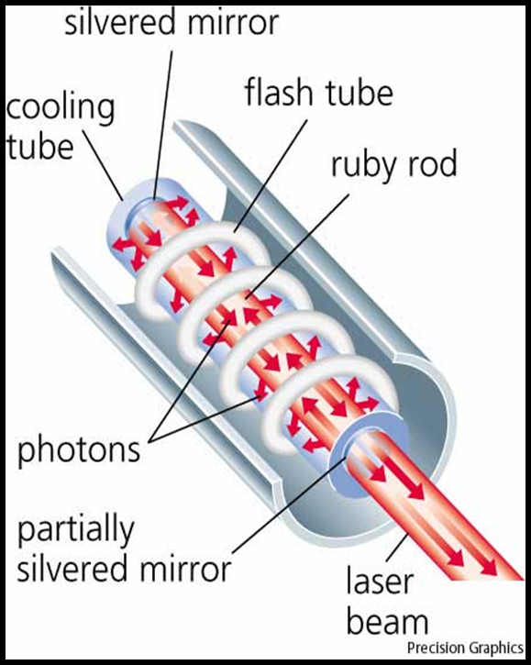 | Word Bank:  Silvered Mirror  Flash Tube  Ruby Rod  Photons  Cooling Tube  Partially Silvered Mirror  Laser Beam

Short Essay Questions
Video: How a Laser Works
Before the Video | After the Video | Analyze Thoughts
20. What are some uses of Lasers in Industry? (slide 14) | 21. After watching the video, answer the question again: What are some uses of Lasers in Industry? (slide 15-16) | 22. Did the video change what you think about some of the uses of lasers in industry? If so how? (slide 15-16)
Answers will vary | This video point out the use of laser in barcode scanners, DVD players, medicine, laser light shows, and micro manufacturing.  There are other applications students can research and add to the list including  Laser stereo lithography,  Laser targeting  Laser punching and manufacturing  Laser communications | Answers will vary

